Project Design Phase-II
Technology Stack (Architecture & Stack)
Date | 31 January 2025
Team ID | ________________
Project Name | Implement Client Script & UI Policy (Incident)
Maximum Marks | 4 Marks

Technical Architecture:
The deliverable includes the architectural diagram and information represented in Table-1 and Table-2.
Project Architecture Diagram
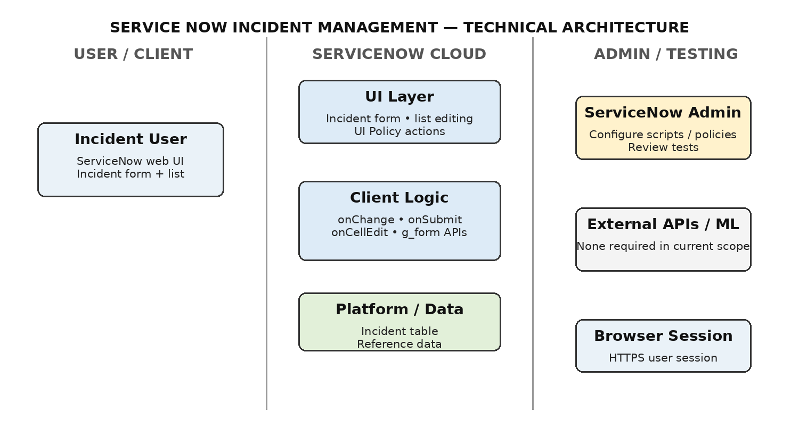
The architecture uses the ServiceNow platform, with the browser as the interface, UI Policy and Client Scripts as application logic, and the Incident table as the primary data store.

Table-1 : Components & Technologies
S.No | Component | Description | Technology
1 | User Interface | Incident form and Incident list. | ServiceNow web UI / browser
2 | Application Logic-1 | Dynamic field behaviour based on Impact. | UI Policy — High Impact Control
3 | Application Logic-2 | Automatic Urgency update when Impact changes. | Client Script — onChange
4 | Application Logic-3 | Validate Incident submission. | Client Script — onSubmit
5 | Application Logic-4 | Block State changes through list editing. | Client Script — onCellEdit
6 | Database | Stores Incident records and field values. | ServiceNow Incident [incident] table
7 | Reference Data | User and assignment information. | ServiceNow user/group reference data
8 | External API | Not required in project scope. | Not applicable
9 | Machine Learning Model | Not required for rule-based Incident controls. | Not applicable
10 | Infrastructure | Application and configuration hosted in the instance. | ServiceNow Cloud / Browser

Table-2: Application Characteristics
S.No | Characteristics | Description | Technology
1 | Open-Source Frameworks | No additional open-source application framework is required. | ServiceNow platform scripting
2 | Security Implementations | ServiceNow roles/ACLs plus client-side UI controls. | ServiceNow ACLs / roles
3 | Scalable Architecture | Table-level rules execute only for relevant Incident events. | ServiceNow platform
4 | Availability | Depends on ServiceNow instance and browser/network session. | ServiceNow Cloud
5 | Performance | Small event-driven scripts limited to relevant fields/events. | Client-side JavaScript / ServiceNow APIs
References
• ServiceNow platform documentation / developer resources
• C4 model architecture concepts used as a diagramming reference

